Principal Components Analysis (PCA)

What is PCA?

PCA transforms a set of correlated variables into a new, smaller set of uncorrelated variables. These new variables are known as principal components (PCs). The PCs are formed by finding linear combinations of the original variables.

For example, with the cereal data, perhaps we could represent the adjusted sugar, fat, and sodium variables by ONLY

y = -0.667sugar – 0.5879fat + 0.4575sodium

without really losing much information about the data. We will examine later if this is true.

Objectives of PCA

PCA is used primarily as an exploratory technique to be followed up with other analyses. The objectives of PCA are to

- Discover the “true dimension” of the data

If our p original variables can be represented well with just d principal components (d < p) without losing much information, then do it!

The word “dimension” is often used with this to essentially mean number of variables. For example, if we have 10 variables, it is difficult to view graphically all 10 variables simultaneously in a scatter plot (10D or 10-dimensional scatter plot). However, if we can find 3 PCs that essentially represent the 10 original variables without much loss of information, we can view the PCs with just a 3D scatter plot!

- Try to interpret the PCs (“new” variables)

The PCs are linear combinations of the “original” variables. The weights for each of the original variables may give meaning to the PCs. For example, a weight of 0 could mean that a particular original variable is not important to the PC.

Finding interpretations for the PCs often is VERY difficult.

Uses of PCA

- Data screening

Although plotting can help to identify outliers, it may be difficult when there are MANY variables. PCA will help view the data with a smaller number of variables that may help identify outliers.

- Clustering

Determine how to group like observations. More formal ways are discussed later in our course.

- Predict classifications

When classifications of the observations are already known, PCA can be used to help develop ways to predict classifications. More formal ways are discussed later in our course.

- Regression analysis

When explanatory (independent) variables are highly correlated with each other, “intercorrelation” or “multicollinearity” is said to exist. This can cause estimates of the β’s to be “unstable” (meaning that from sample-to-sample-to-sample, the ’s have a lot of variability). Therefore, interpretation of how an explanatory and response (dependent) variable are related by examining the may not give good results.

PCA with the covariance matrix Σ

Characteristics of the PCs:
- Uncorrelated (represent distinct parts of data)
- First principal component accounts for as much of the remaining variability in the data as possible
- Each successive principal component accounts for as much variability in the data as possible (but always less than the previous PC)

Let x ~ (μ, Σ) where x is p×1. Notice that we do not use a multivariate normal distribution assumption.

First principal component

= a₁₁(x₁-μ₁) + a₂₁(x₂-μ₂) + … + a_{p1}(x_{p}-μ_{p})

where a₁ = [a₁₁, …, a_{p1}]′ is a p×1 vector chosen so that Var[] is maximized over all vectors a₁ with a length of 1.

The maximum value of the variance is the largest eigenvalue of Σ, λ₁. The variance occurs when a₁ is the corresponding eigenvector of Σ. For a proof, see Johnson and Wichern’s textbook.

Because the variance of is being maximized, the new variable y₁ will explain as much variability of x as possible.

Why are we concerned about explaining variability? In statistics, we often equate “variability” with “information”. The more variability that you understand about a data set, the more information that you know about the data set. Refer back to when you were introduced to ANOVA or regression methods when explaining variability was focused on.

Second principal component

where a₂ is chosen so that Var[] is maximized over all possible vectors a₂ with a length of 1 and y₁ and y₂ are uncorrelated. The uncorrelated part implies then that a₁ and a₂ are orthogonal (i.e., ).

The maximum value is λ₂ (2nd largest eigenvalue from Σ) and it occurs when a₂ is the corresponding eigenvector of Σ.

Third, fourth,… principal component

Found in a similar manner as the first and second PCs.

It can be shown that because the eigenvectors are orthogonal, the PCs are orthogonal. This allows an orthogonal axis system to be used with the PCs

For example, we can use a graph with x, y, and z axes like “usual” if there are three principal components. Later in the course, we will learn about ways to not have orthogonal axes.

Question: How many principal components can one have?

Total variance

The covariance matrix can be written as:

The total variance is the sum of the diagonal elements:

This can be thought of as a measure of the total amount of information in the original variables.

From the matrix algebra subsection, remember that . A measure of the importance of the j^{th} principal component is then . Note that this is a proportion and remember that Var(y_{j}) = λ_{j}. The larger the value, the more variability the j^{th} principal component accounts for.

Determining the number of PCs

We would like to find the smallest number of PCs such that most of the data set variability is accounted for. The dimensionality of the data essentially corresponds to the number of non-zero eigenvalues.

How can we determine the number of PCs then?

- Account for 100γ% of the variability where 0 < γ < 1

Find the smallest value d such that > γ, where d is the number of PCs that you choose.

- Examine a scree plot

Plot vs. 1, 2, …, p. When the points on the plot level off close to 0, the corresponding PCs are probably not contributing too much information to understanding the data. The value of d is the number of eigenvalues before the leveling off occurs.

Example:
Choose d = 2 since the plot levels off at .

Estimation

Because μ and Σ are usually NEVER known, the corresponding estimates

are used instead in calculations. Therefore, we will from now on use

for j =1,…,p

where the j^{th} largest eigenvalue of and its corresponding eigenvector are denoted by and , respectively.

Interpretation

Elements of = [, ,…, ] are often compared within to try to interpret the PCs. For example, suppose is “large” positive and “large” negative while the other components are approximately 0. The PC can be thought of as measuring the difference between the 1st and 2nd original variable. This may have a meaningful interpretation.

PC scores

What are the actual numerical values of the PCs for each observation?

For each observation, we calculate the j^{th} principal component value or score as:

for the j^{th} PC and the r^{th} observation.

Example: Goblet data (GobletPCA.R, goblet.csv)

Below is the picture of the measurements from earlier in the notes:

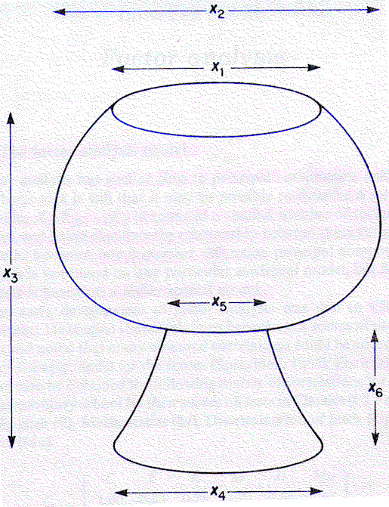

From a past practice problem:

Researchers are interested in grouping goblets that have the same shape although they may have different sizes. One way suggested by Manly and Alberto (2016) is to adjust the data by dividing each measurement by X₃ (height).

> goblet <- read.csv("C:\\chris\\goblet.csv")
> head(goblet)
goblet x1 x2 x3 x4 x5 x6
1 1 13 21 23 14 7 8
2 2 14 14 24 19 5 9
3 3 19 23 24 20 6 12
4 4 17 18 16 16 11 8
5 5 19 20 16 16 10 7
6 6 12 20 24 17 6 9

> goblet2 <- data.frame(ID = goblet$goblet,
w1 = goblet$x1/goblet$x3,
w2 = goblet$x2/goblet$x3,
w4 = goblet$x4/goblet$x3,
w5 = goblet$x5/goblet$x3,
w6 = goblet$x6/goblet$x3)
> head(goblet2)
ID w1 w2 w4 w5 w6
1 1 0.5652174 0.9130435 0.6086957 0.3043478 0.3478261
2 2 0.5833333 0.5833333 0.7916667 0.2083333 0.3750000
3 3 0.7916667 0.9583333 0.8333333 0.2500000 0.5000000
4 4 1.0625000 1.1250000 1.0000000 0.6875000 0.5000000
5 5 1.1875000 1.2500000 1.0000000 0.6250000 0.4375000
6 6 0.5000000 0.8333333 0.7083333 0.2500000 0.3750000

Star plot:

> dev.new(width = 11, height = 7)
> stars(x = goblet2[,-1], draw.segments = TRUE, key.loc =
c(14,10), main = "Goblet star plot", labels =
goblet2$ID)
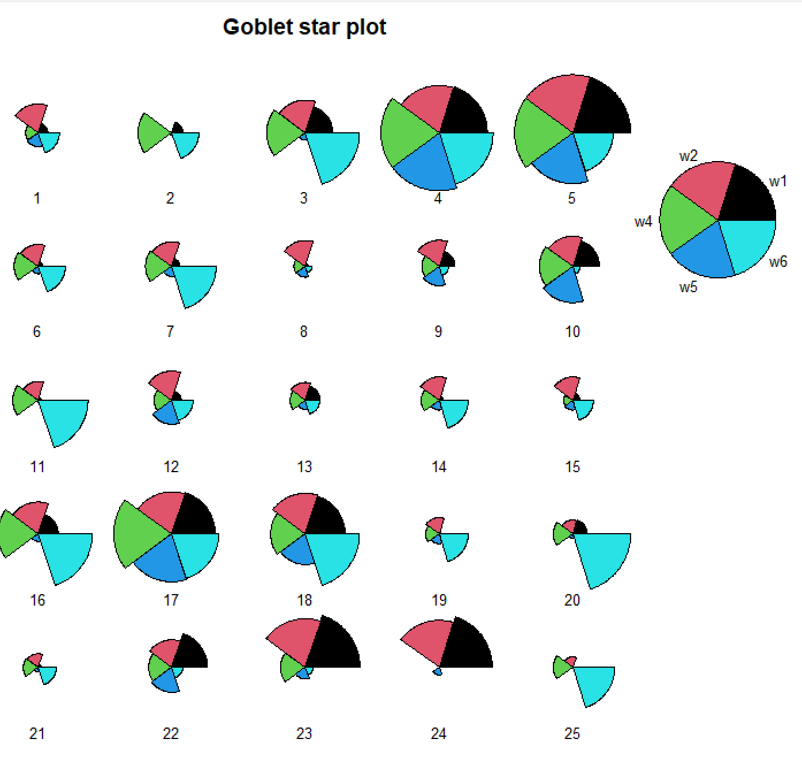

Which goblets appear to stand out? Can you make any generalizations about groups for goblets?

Parallel coordinates plot:

> library(MASS)
> col.w5 <- ifelse(test = goblet2$w5 <= median(goblet2$w5), yes = "red", no = "blue")
> parcoord(x = goblet2[,-1], col = col.w5, main = "Goblet
parallel coordinate plot")
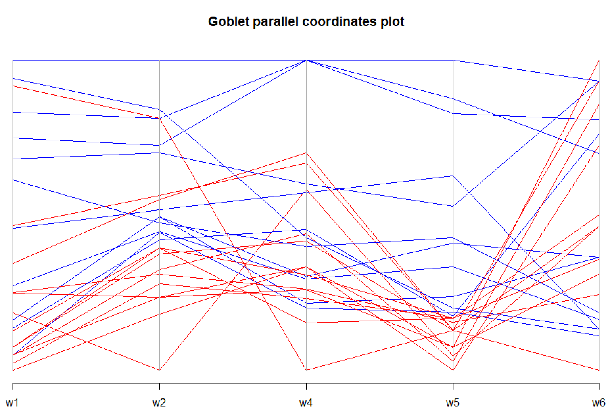

As mentioned in the partial answers for the practice problems, it appears that a large connection between the base and the cup leads to larger values of w1, w2, and w4 (see highlighted lines above). The same type of highlighting for other variables does not produce similar results.

PCA with the estimated covariance matrix:

> pca.cov <- princomp(formula = ~ w1 + w2 + w4 + w5 + w6,
data = goblet2, cor = FALSE)
> pca.cov
Call:
princomp(formula = ~w1 + w2 + w4 + w5 + w6, data = goblet2, cor = FALSE)

Standard deviations:
Comp.1 Comp.2 Comp.3 Comp.4 Comp.5
0.30317016 0.13231201 0.08424389 0.06511770 0.03822006

5 variables and 25 observations.

There is not much information given by simply printing the object. Next, I examine exactly what information is available inside the object and what method functions are available to summarize this information.

> names(pca.cov) #What's inside pca.cov?
[1] "sdev" "loadings" "center" "scale" "n.obs"
[6] "scores" "call"
> class(pca.cov) #Class of pca.save
[1] "princomp"

> #Method functions for objects of class princomp
> methods(class = princomp)
[1] biplot plot predict print summary
see '?methods' for accessing help and source code

Below is the output from using the summary() function:

> summary(pca.cov, loadings = TRUE, cutoff = 0.0)
Importance of components:
Comp.1 Comp.2 Comp.3
Standard deviation 0.3031702 0.1323120 0.08424389
Proportion of Variance 0.7520422 0.1432412 0.05806924
Cumulative Proportion 0.7520422 0.8952834 0.95335264
Comp.4 Comp.5
Standard deviation 0.06511770 0.03822006
Proportion of Variance 0.03469505 0.01195231
Cumulative Proportion 0.98804769 1.00000000

Loadings:
Comp.1 Comp.2 Comp.3 Comp.4 Comp.5
w1 0.758 0.344 0.378 0.368 0.171
w2 0.460 0.194 -0.200 -0.802 -0.259
w4 0.287 -0.697 0.194 0.146 -0.612
w5 0.362 -0.369 -0.739 0.174 0.397
w6 0.036 -0.472 0.484 -0.411 0.610

> mu.hat <- colMeans(goblet2[,-1])
> mu.hat
w1 w2 w4 w5 w6
0.7079462 0.9040548 0.7231692 0.3303339 0.3882952

> goblet2[1,]
ID w1 w2 w4 w5 w6
1 1 0.5652174 0.9130435 0.6086957 0.3043478 0.3478261

- The “Standard deviation” row in the “Importance of components” table gives the standard deviation of each principal component in the first row. Therefore, we have
- The “Proportion of Variance” row in the “Importance of components” table gives . Two PCs may be enough because 89.5% of the total variability is accounted for by them. Three PCs would definitely be enough (95.3% of the total variability).
- The “Loadings” table gives the eigenvectors. The “loadings” name comes from the eigenvectors being the coefficients in the linear combination with the data.
- The eigenvectors are orthogonal to each other. For example, = 0.758∗0.344 + + 0.036∗(-0.472) = 0.
- The eigenvectors have a length of 1. For example, = [0.758² + + 0.036²]^{1/2} = 1.

First PC:

What is the second PC?

To calculate the PC scores, we can use the above equations with the variable values. For example, the score for the first PC is

The scores component of pca.cov contains all of the scores. The predict() function can be used to find these as well.

> score.cor2 <- pca.cov$scores
> head(score.cor2)
Comp.1 Comp.2 Comp.3 Comp.4
1 -0.14765328 0.06106004 -0.07828190 -0.064361319
2 -0.26695271 -0.10141822 0.11386906 0.205631593
3 0.09490966 -0.06056653 0.15554367 -0.056555038
4 0.58278467 -0.21248552 -0.06625086 0.009916689
5 0.71019359 -0.09271586 -0.02809389 -0.029515624
6 -0.22386733 -0.03900914 -0.01442359 -0.030554186
Comp.5
1 0.008322769
2 -0.036653466
3 -0.030894377
4 0.043937358
5 -0.030048015
6 -0.048100304

> # The predict function can be used as well
> head(predict(pca.cov))
Comp.1 Comp.2 Comp.3 Comp.4
1 -0.14765328 0.06106004 -0.07828190 -0.064361319
2 -0.26695271 -0.10141822 0.11386906 0.205631593
3 0.09490966 -0.06056653 0.15554367 -0.056555038
4 0.58278467 -0.21248552 -0.06625086 0.009916689
5 0.71019359 -0.09271586 -0.02809389 -0.029515624
6 -0.22386733 -0.03900914 -0.01442359 -0.030554186
Comp.5
1 0.008322769
2 -0.036653466
3 -0.030894377
4 0.043937358
5 -0.030048015
6 -0.048100304

> sum(pca.cov$loadings[,1]*(goblet2[1,-1] - mu.hat))
[1] -0.1476533

Scree plot:

> plot(pca.cov, type = "lines", main = "Scree plot for cereal data")
> # screeplot(pca.cov, type = "lines") # Also works
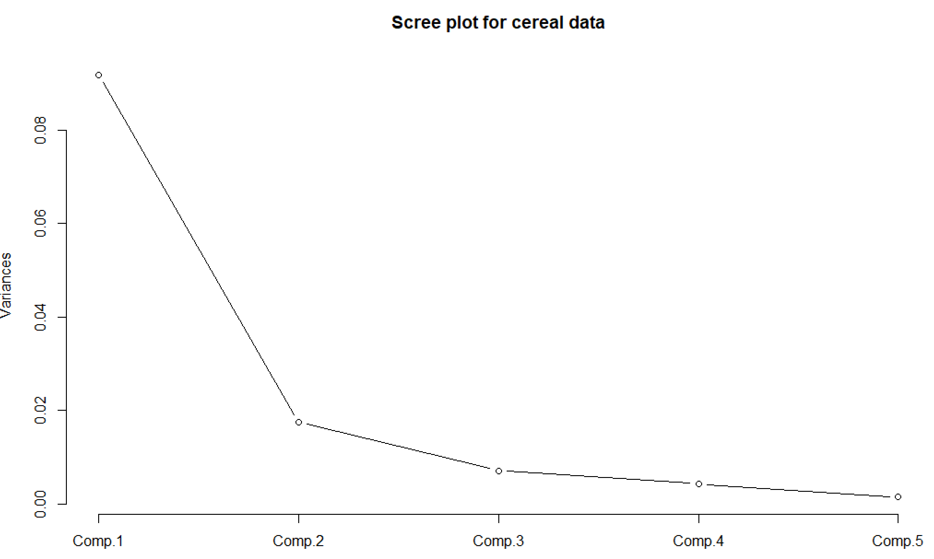

The plot suggests one or two PCs may be enough. I would prefer to use two because 89.5% of the total variability is accounted for by them. Also, it is easy to display the scores of two PCs in a scatter plot (shown shortly).

Interpretation the PCs:
- PC #1 is a measure of the overall width of the goblet.
- PC #2 is measuring the difference between w₁ and w₂ (top) versus w₄, w₅, and w₆ (base).
- PC #3 appears to be measuring the difference between w₁, w₄, and w₆ versus w₂ and w₅. Interpretation???

An important part of making these interpretations is that the original variables are measured in the same units.

Below are plots of the PCs:

> common.limits <- c(min(score.cor2[,1:2]), max(score.cor2[,1:2]))
> plot(x = score.cor2[,1], y = score.cor2[,2], xlab = "PC #1", ylab = "PC #2", main = "Principal components", xlim = common.limits, ylim = common.limits, panel.first = grid(col = "lightgray", lty = "dotted"))
> abline(h = 0)
> abline(v = 0)
> text(x = score.cor2[,1], y = score.cor2[,2]+0.03)

> #Bubble plot of first three PCs
> summary(score.cor2[,3])
Min. 1st Qu. Median Mean 3rd Qu. Max.
-0.13839 -0.05606 -0.01783 0.00000 0.06390 0.15554

> #Bubble needs to contain all values > 0
> PC3.positive2 <- score.cor2[,3] - min(score.cor2[,3])
> symbols(x = score.cor2[,1], y = score.cor2[,2], circles = PC3.positive2, xlab = "PC #1", ylab = "PC #2", main = "Principal components", inches = 0.5, xlim = common.limits, ylim = common.limits, panel.first = grid(col = "lightgray", lty = "dotted"))
> text(x = score.cor2[,1], y = score.cor2[,2])
> abline(h = 0)
> abline(v = 0)
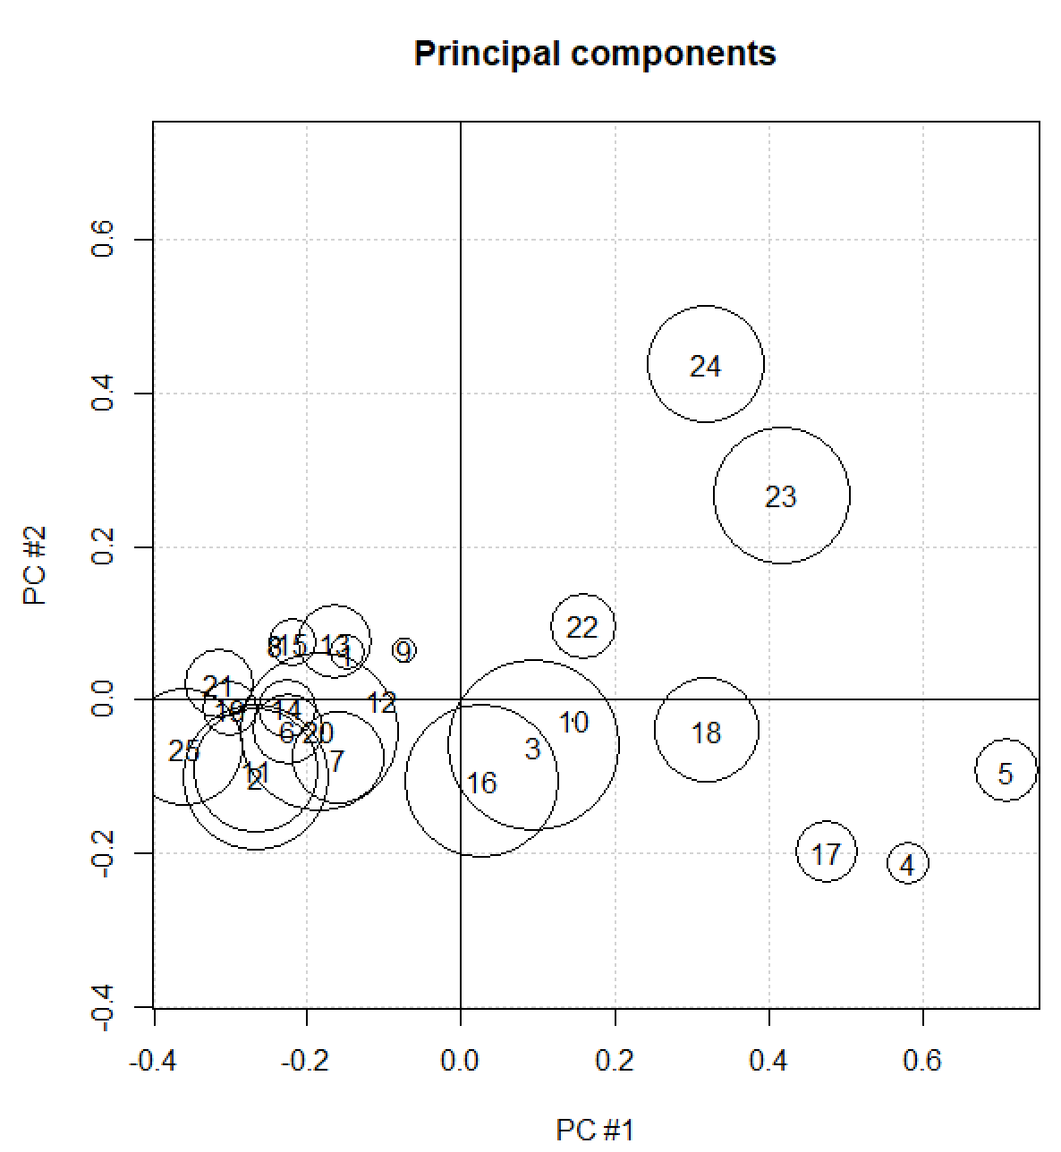

> #Different colors for positive and negative PC #3
> col.symbol <- ifelse(test = score.cor2[,3]>0, yes = "red", no = "blue")
> symbols(x = score.cor2[,1], y = score.cor2[,2], circles = PC3.positive2, xlab = "PC #1", ylab = "PC #2", main = "Principal components", inches = 0.5, xlim = common.limits, ylim = common.limits, panel.first = grid(col = "lightgray", lty = "dotted"), fg = col.symbol)
> text(x = score.cor2[,1], y = score.cor2[,2])
> abline(h = 0)
> abline(v = 0)
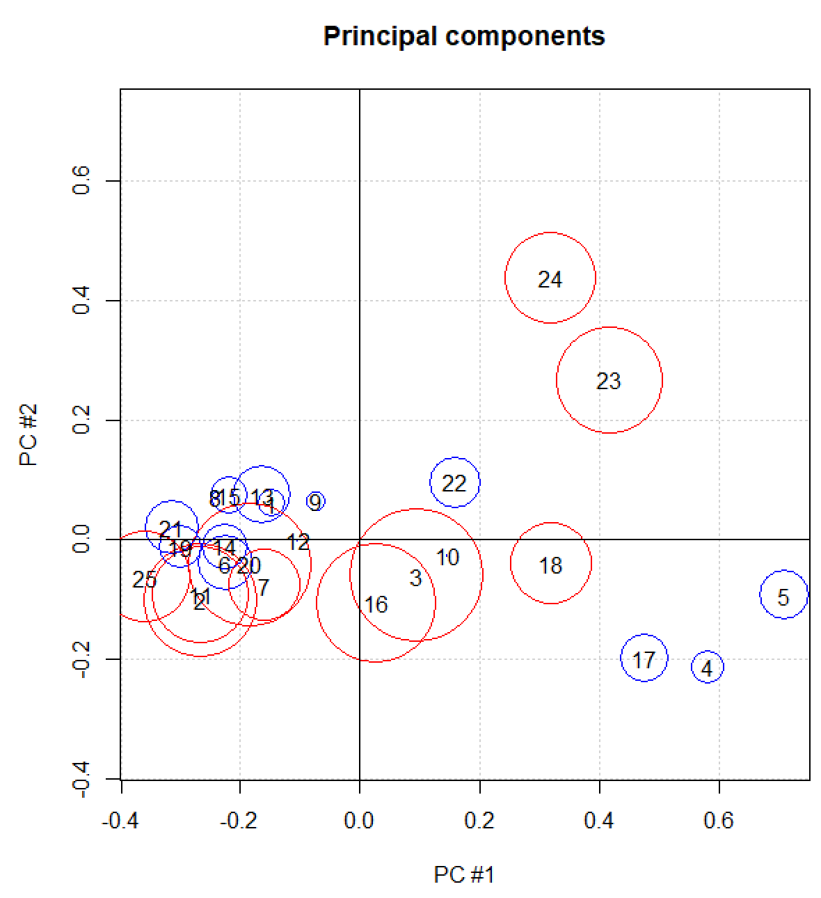

> #3D plot
> library(rgl)
> plot3d(x = score.cor2[,1], y = score.cor2[,2], z = score.cor2[,3], xlab = "PC #1", ylab = "PC #2", zlab = "PC #3", type = "h", xlim = common.limits, ylim = common.limits)
> plot3d(x = score.cor2[,1], y = score.cor2[,2], z = score.cor2[,3], add = TRUE, col = "red", size = 6)
> persp3d(x = common.limits, y = common.limits, z = matrix(data = c(0,0,0,0), nrow = 2, ncol = 2), add = TRUE, col = "green")
> grid3d(side = c("x", "y", "z"), col = "lightgray")
> text3d(x = score.cor2[,1], y = score.cor2[,2], z = ore.cor2[,3]+0.02, text = 1:nrow(goblet2))
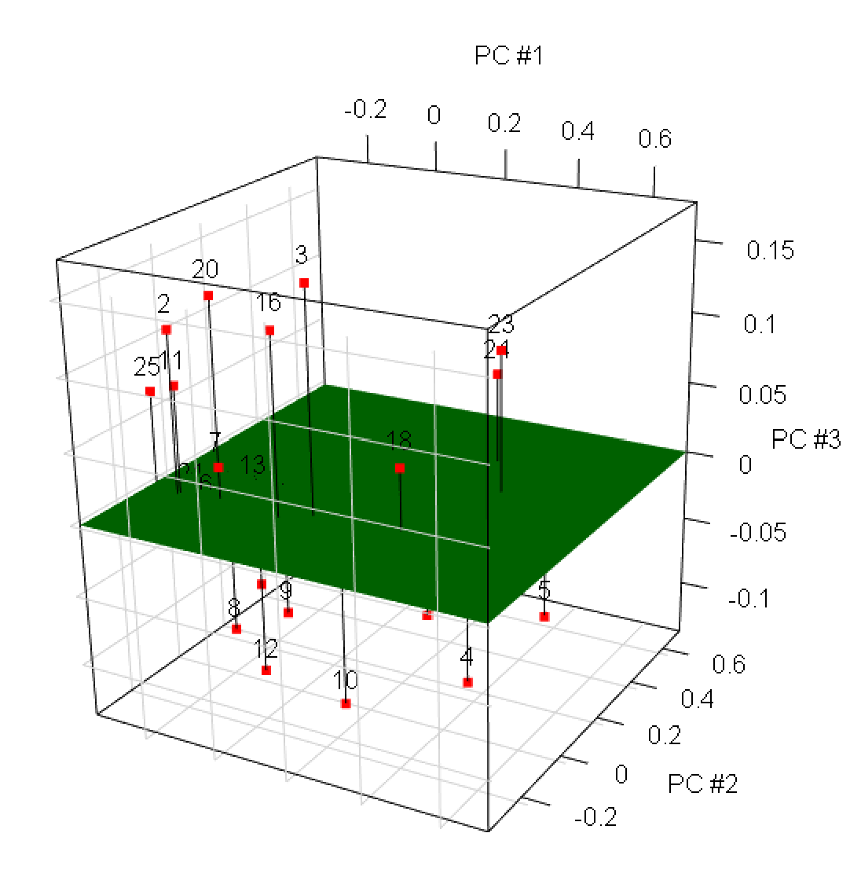
I could include zlim = common.limits in the first plot3d() as well so that all axes are on the same scale.

Questions:
- Are there any outliers?
- Are there possible groupings?

After the analysis is complete, suppose new goblets are found. How can one obtain the PC scores for these new goblets? Use the predict() function. The new observations can be specified in the newdata argument of predict(). Below is a small example where a new observation happens to be the same as the first observation already in the data set.

> goblet2[1,] #To make this easy, let's use the first
observation values
ID w1 w2 w4 w5 w6
1 1 0.5652174 0.9130435 0.6086957 0.3043478 0.3478261

> pred.set <- data.frame(w1 = 0.5652174, w2 = 0.9130435, w4 = 0.6086957, w5 = 0.3043478, w6 = 0.3478261)
> predict(object = pca.cov, newdata = pred.set)
Comp.1 Comp.2 Comp.3 Comp.4
[1,] -0.1476533 0.06106002 -0.07828186 -0.06436134
Comp.5
[1,] 0.008322733

Calculations by princomp()

One could simply use the eigen() function to obtain the eigenvalues and corresponding vectors from the covariance matrix rather than using princomp(). If this was done, you will notice that there will be small differences! This is because princomp() uses the “biased” version of the estimated covariance matrix rather than the “unbiased” version.

This means that the estimated covariance matrix is calculated as

,

the usual “biased” estimate, rather than the unbiased estimate

that we have been using.

What happens to these values as N gets large?

In the end, there will not be meaningful difference in the PC interpretations and in the scores, so we will use the results as given by princomp() and the scores as given by $scores or predict().

Possible issues with PCA

- If the original set of variables are already uncorrelated, PCA will not help. Why?
- PCA does not generally eliminate variables because the PCs are linear combinations of the original variables.
- The original variables need to be measured in the same units and have similar variances.

Remember that PCA relies heavily on examining the variances of the original variables. Larger variance variables will dominate the other variables in the analysis.

For example, suppose there are three variables x₁, x₂, and x₃ with variances of 98, 1.9, and 0.1, respectively. A way to maximize the variance of the first PC is to have it consist primarily of x₁. For example, suppose we choose

y₁ = a₁₁(x₁-μ₁) + a₂₁(x₂-μ₂) + a₃₁(x₃-μ₃)
= 1(x₁-μ₁) + 0(x₂-μ₂) + 0(x₃-μ₃)
= x₁-μ₁

In this situation, the first principal component accounts for 98% of the variation in the data! It would very difficult to have any other linear combination that works significantly better. Also, in this situation (depending on the correlations between the variables), the second linear combination will likely be just for x₂ and the third linear combination will likely be just for x₃. Thus, we are left with what had originally with the data. We will look at an actual data example shortly where something similar happens.

A solution to this problem is to use standardized data. Equivalently, use P in place of Σ because the P is the covariance matrix of standardized random variables.

Note that there may be situations where one wants to weight one variable more than another. For example, suppose all of the variables are measured in the same numerical scale and you want the actual differences in these measurements to matter. This may be the case for the goblet data.

PCA with the Correlation Matrix P

PCA is most often performed using the correlation matrix P rather than the covariance matrix Σ to eliminate the problem with different numerical scales being used with variables.

Again, because P will not be known, we will use the estimated correlation matrix R. The corresponding eigenvalues and eigenectors for R are denoted by and , respectively. On your own, make sure you can write out the PCs!

where is the r^{th} PC when using the standardized variables.

Determining the number of PCs

- Account for γ% of the variability
- Scree plot
- Find the number of eigenvalues greater than 1

What is the reason for the last bullet?

The analysis is being performed with “standardized data”. If a principal component does not account for more variability than an original variable (1), it may not be important.

PC scores

For each observation, we calculate the j^{th} principal component value or score as:

for the j^{th} PC and the r^{th} observation.

There is a very small calculation issue with princomp() and predict(). While the correlation matrix is not affected by using 1/N vs. 1/(N – 1) in the covariance matrix (these values cancel out), the values of are affected. The standardized values will use the biased estimate of the standard deviation in their calculation. The next example shows a small piece of code to fix the issue.

Example: Goblet data (GobletPCA.R, goblet.csv)

Below is the output for using the correlation matrix:

> pca.cor <- princomp(formula = ~ w1 + w2 + w4 + w5 + w6,
data = goblet2, cor = TRUE, scores = FALSE)
> summary(pca.cor, loadings = TRUE, cutoff = 0.0)
Comp.1 Comp.2 Comp.3
Standard deviation 1.7449238 1.1330854 0.63601891
Proportion of Variance 0.6089518 0.2567765 0.08090401
Cumulative Proportion 0.6089518 0.8657283 0.94663232
Comp.4 Comp.5
Standard deviation 0.42528233 0.29321207
Proportion of Variance 0.03617301 0.01719466
Cumulative Proportion 0.98280534 1.00000000

Loadings:
Comp.1 Comp.2 Comp.3 Comp.4 Comp.5
w1 0.495 0.311 0.393 0.511 0.492
w2 0.490 0.330 0.393 -0.494 -0.502
w4 0.473 -0.412 -0.274 0.508 -0.523
w5 0.505 0.057 -0.666 -0.384 0.387
w6 0.190 -0.788 0.415 -0.299 0.286

Comments:
- PC #1 is a measure of the overall size of the goblet with not as much weight given to w₆.
- PC #2 is measuring the difference between w₁ and w₂ (top) versus w₄ and w₆ (base). Note that w₅ does not play a large role because its value is close to 0. Negative values of indicate a large base (relative to height) and positive values indicate a large top (relative to height).
- PC #3 appears to be measuring the difference between w₁, w₂, and w₆ versus w₄ and w₅. Interpretation???

Two PCs may be enough because 86.6% of the total variability is accounted for by them. Three PCs would definitely be enough (94.7% of the total variability). Notice that the third eigenvalue is less than 1, so the third PC accounts for less variability than an original variable.

Below are the plots for the PCs when using the correlation matrix.

> # Fix issue with 1/N vs. 1/(N-1)
> pca.cor$scale <- apply(X = goblet2[,-1], MARGIN = 2, FUN = sd)
> score.cor <- predict(pca.cor, newdata = goblet2)
> head(score.cor)
Comp.1 Comp.2 Comp.3 Comp.4
[1,] -0.8550658 0.5550454 -0.04593840 -0.553059990
[2,] -1.4929780 -0.9805278 -0.63447839 1.400864315
[3,] 0.6925848 -1.1866658 0.97492541 0.254414390
[4,] 3.9497633 -0.8219633 -0.60111958 -0.273882618
[5,] 4.2321986 0.1571450 -0.08857736 -0.015618439
[6,] -1.0207748 -0.2810525 -0.16578953 -0.002166875
Comp.5
[1,] -0.07643603
[2,] 0.12848295
[3,] -0.28689963
[4,] 0.28578644
[5,] -0.24777873
[6,] -0.40365104

> par(pty = "s")
> common.limits <- c(min(score.cor[,1:2]),
max(score.cor[,1:2]))
> plot(x = score.cor[,1], y = score.cor[,2], xlab = "PC
#1", ylab = "PC #2", main = "Principal components",
xlim = common.limits, ylim = common.limits, panel.first
= grid(col = "lightgray", lty = "dotted"))
> abline(h = 0)
> abline(v = 0)
> text(x = score.cor[,1], y = score.cor[,2]+0.2)

> summary(score.cor[,3])
Min. 1st Qu. Median Mean 3rd Qu. Max.
-1.25300 -0.46400 -0.08858 0.00000 0.44480 1.40400
> # Bubble needs to contain all values > 0
> PC3.positive <- score.cor[,3] - min(score.cor[,3])
> symbols(x = score.cor[,1], y = score.cor[,2], circles =
PC3.positive, xlab = "PC #1", ylab = "PC #2", main =
"Principal components", inches = 0.5, xlim =
common.limits, ylim = common.limits, panel.first =
grid(col = "lightgray", lty = "dotted"))
> text(x = score.cor[,1], y = score.cor[,2])
> abline(h = 0)
> abline(v = 0)

> # Different colors for positive and negative PC #3
> col.symbol <- ifelse(test = score.cor[,3]>0, yes = "red", no = "blue")
> symbols(x = score.cor[,1], y = score.cor[,2], circles = PC3.positive, xlab = "PC #1", ylab = "PC #2", main = "Principal components", inches = 0.5, xlim = common.limits, ylim = common.limits, panel.first = grid(col = "lightgray", lty = "dotted"), fg = col.symbol)
> text(x = score.cor[,1], y = score.cor[,2])
> abline(h = 0)
> abline(v = 0)

> pos.PC3 <- score.cor[,3]>0
> symbols(x = score.cor[pos.PC3,1], y = score.cor[pos.PC3,
2], circles = PC3.positive[pos.PC3], xlab = "PC #1",
ylab = "PC #2", main = "Principal components", inches =
0.5, xlim = common.limits, ylim = common.limits,
panel.first = grid(col = "lightgray", lty = "dotted"),
fg = "red")
> symbols(x = score.cor[!pos.PC3,1], y =score.cor[!pos.PC3,
2], circles = PC3.positive[!pos.PC3], inches =
0.5, fg = "blue", add = TRUE)
> text(x = score.cor[,1], y = score.cor[,2])
> abline(h = 0)
> abline(v = 0)

> library(rgl)
> plot3d(x = score.cor[,1], y = score.cor[,2], z =
score.cor[,3], xlab = "PC #1", ylab = "PC #2", zlab =
"PC #3", type = "h", xlim = common.limits, ylim =
common.limits)
> plot3d(x = score.cor[,1], y = score.cor[,2], z =
score.cor[,3], add = TRUE, col = "red", size = 6)
> persp3d(x = common.limits, y = common.limits,
z = matrix(data = c(0,0,0,0), nrow = 2, ncol = 2), add
= TRUE, col = "green") #Plane
> grid3d(side = c("x", "y", "z"), col = "lightgray")
> text3d(x = score.cor[,1], y = score.cor[,2], z = score.cor[,3] + 0.2, text = 1:nrow(goblet2))
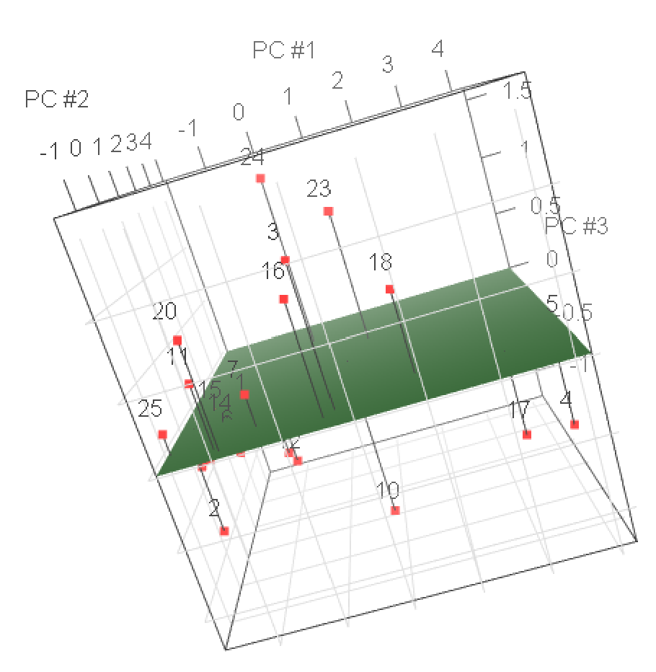
Need to rotate the plot to get a good view.

Comments:
- Notice that there appears to be more variability for PC #1 than PC #2 in the scatter plot. Again, this would be expected due to how PCs are found. In the 3D scatter plot, there is even less variability for PC #3. Make sure you take into account the z-axis scale when comparing PC #3 to PC #1 and PC #2 (I did not here so that the points were easier to see).
- Possible outliers: Goblets #10, #23, #24; examine where #4, #5, #17, and #18 are because we had identified these before with the stars plot
- “Possible” groupings – These are drawn on the bubble plot below with the help of the 3D scatter plot. Note that it can also be helpful to view the 3D scatter plot so that PC #1 or PC #2 are examined straight on. This allows you to essentially look at this one dimension with PC #3

Using PC #1 and PC #2, below are descriptions of the goblet groups:
- Red – Large in overall size
- Blue – Larger cups (tops) relative to the base
- Green – Smaller in overall size than many other goblets
- Yellow – Somewhat smaller cups relative to the base

Because the interpretation for PC #3 is difficult, I did not include it here in my goblet group descriptions. Hopefully, this is where a researcher could provide some insight to the meaning of PC #3 so that it could be included in the interpretation.

Example: Cereal data (CerealPCA.R, cereal.csv)

Because the cereal data has only 3 variables of interest (sugar, fat, and sodium), a PCA probably would not be of interest. However, because the number of variables is small, it is easier to use this data to demonstrate the methods.

How well do you think PCA will work for this data given the estimated correlation matrix?

> cor(cereal[,8:10])
sugar fat sodium
sugar 1.0000000 0.2397225 -0.1635699
fat 0.2397225 1.0000000 -0.0661432
sodium -0.1635699 -0.0661432 1.0000000

Because sodium is measured on a different scale than fat and sugar content, using the correlation matrix in the PCA would be better than using the covariance matrix.

One could transform sodium from mg to grams and then take sodium/serving size. This would put sugar, fat, and sodium in the same numerical scale. However, given the drastic numerical differences between the sodium and the other variables, I think using the correlation matrix would still be a much better choice.

Below is my R code and output:

> pca.save <- princomp(formula = ~ sugar + fat + sodium, data = cereal, cor = TRUE, scores = TRUE)
> summary(pca.save, loadings = TRUE, cutoff = 0.0)
Importance of components:
Comp.1 Comp.2 Comp.3
Standard deviation 1.1504216 0.9689554 0.8588687
Proportion of Variance 0.4411567 0.3129582 0.2458851
Cumulative Proportion 0.4411567 0.7541149 1.0000000

Loadings:
Comp.1 Comp.2 Comp.3
sugar 0.667 0.091 0.739
fat 0.588 0.545 -0.597
sodium -0.458 0.833 0.310

> eigen(cor(cereal[,8:10]))
$values
[1] 1.3234700 0.9388747 0.7376554

$vectors
[,1] [,2] [,3]
[1,] -0.6670789 0.09084126 0.7394279
[2,] -0.5879285 0.54538679 -0.5974055
[3,] 0.4575433 0.83324733 0.3104079

Comments:
- The “Standard deviation” row in the “Importance of components” table gives the standard deviation of each principal component in the first row. Therefore, we have , , and .
- The “Proportion of Variance” row in the “Importance of components” table gives /tr(R) = /3. None of the eigenvalues have a large proportion. This indicates that the true dimension may be 3.
- The “Loadings” table gives the eigenvectors. The “loadings” name comes from the eigenvectors being the coefficients in the linear combination with the data.
- The eigenvectors are orthogonal to each other. For example, = 0.667∗(-0.091) + 0.588∗0.545 - 0.458∗0.833 = 0.
- The eigenvectors are normalized to have a length of 1. For example, = [0.667² + 0.588² + (-0.458)²]^{1/2} = 1.
- Notice the eigenvectors given by eigen() are multiplied by -1 in comparison to what princomp() gives us. Why is this not of concern?
- Scree plot

> plot(pca.save, type = "lines", main = "Scree plot for
cereal data")
> #screeplot(x = pca.save, type = "lines", main = "Scree
plot for cereal data") #Same
Be careful with the y-axis scale here (does not start at 0). How many PCs should be used?
- Because the true dimension of the data set does not appear to be less than the original, interpretation of the PCs probably should not be done. If it was done, the first principal component is measuring the sugar and fat content vs. the sodium content. Provided it makes sense to a researcher, this may offer a useful interpretation of the data set.

For illustration purposes, below are the variances of the PCs. Notice that they are the same as the eigenvalues.

> #Create a new list
> pca.save2 <- pca.save
> #Replace standard deviations
> save.score <- predict(pca.save)
> apply(X = save.score, MARGIN = 2, FUN = var)
Comp.1 Comp.2 Comp.3
1.3234700 0.9388747 0.7376554
> pca.save$sdev^2
Comp.1 Comp.2 Comp.3
1.3234700 0.9388747 0.7376554

Using the covariance matrix instead

Again, this is done for illustrative purposes:

> cov(cereal[,8:10])
sugar fat sodium
sugar 0.0223681533 0.0009926903 -0.060242015
fat 0.0009926903 0.0007666194 -0.004509788
sodium -0.0602420149 -0.0045097883 6.064039752

> N <- nrow(cereal)
> cov(cereal[,8:10])*(N-1)/N
sugar fat sodium
sugar 0.021808949 0.0009678730 -0.058735965
fat 0.000967873 0.0007474539 -0.004397044
sodium -0.058735965 -0.0043970436 5.912438758
> sum(diag(cov(cereal[,8:10])*(N-1)/N)) #tr(sigma^_bias)
[1] 5.934995

> pca.cov <- princomp(formula = ~ sugar + fat + sodium, data = cereal, cor = FALSE)
> summary(pca.cov, loadings = TRUE, cutoff = 0.0)
Importance of components:
Comp.1 Comp.2 Comp.3
Standard deviation 2.4316718 0.145825069 0.0265059505
Proportion of Variance 0.9962986 0.003582977 0.0001183767
Cumulative Proportion 0.9962986 0.999881623 1.0000000000

Loadings:
Comp.1 Comp.2 Comp.3
sugar 0.010 0.999 0.045
fat 0.001 0.045 -0.999
sodium -1.000 0.010 0.000

Comments:
- Note that princomp() here uses the biased estimated covariance matrix.
- There is “more” variability for sodium than for sugar and fat. This is because of the units that sodium is measured in.
- The trace of the biased estimate of the covariance matrix is 5.93. This is the total variance.
- = 2.43² = 5.91, = 0.0213, = 0.0007
- The proportion of variability accounted for by the first eigenvalue is 5.91/5.93 = 0.9963. This suggests that the data can be represented in d = 1 dimensions instead of p = 3.
- The first principal component is primarily based on sodium because sugar and fat have values close to 0.

Additional questions:
- Suppose more than 3 PCs are needed for a PCA. How could you represent these graphically?
- Suppose 2D scatter plots and/or 3D scatter plots are used to examine the PCs, but less than 50% of the total variation is accounted for by 3 PCs. Is this o.k. to do?

This could be o.k., but you need to understand that important information in the data could be missed. For example, it is like looking at a scatter plot between x₁ and x₂ without accounting for x₃. This may or may not be o.k. depending on the relationship between all three variables.

- Notice there are no formal inference methods in this subsection. For example, we never calculate a confidence interval for λ_{j}. Interestingly, this is rarely done in practice. This is likely due to PCA being an exploratory technique to be followed up with other analyses.

